**Instructions for annotating “linked” detections**

Aaron Thode

August 2014

This document explains how to load and edit annotations for linked files in Ulysses, formerly known as “All File Specgram Viewer”. Acoustic files from two recorders are considered “linked” if the acoustic recorders were deployed close enough together such that a single bioacoustic “event” (e.g. a whale call) can be detected on both instruments. The linking features in Ulysses allow one to link annotations describing the same event between annotation files, and thus annotate a single event (and its location) simultaneously. As of now, only files that end with the ‘GSI’ extension have this feature. GSI stands for “Greeneridge Sciences Incorporated,” and are files from a particular recorder known as a DASAR**ref**. DASARs are deployed in groups of seven along triangular grids known as “Sites”. The southernmost recorder is labeled “A,” and the northernmost is “G”. DASARs are deployed 7 km apart. The files used here to demonstrate are in jonah.ucsd.edu: /Volumes/Data/Shell2010_GSI_Data/S510gsif/S510D0/. We will be working with the August 31 (0831) files. If asked for a calibration keyword, keep “DASARC” and hit return.

Linking annotation controls and link display

If a GSI file is loaded into Ulysses, the following new controls—“link up,” “link down,” “station up,” and “station down,” appear:

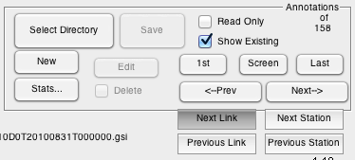

To begin, load Data/Shell2010_GSI_Data/S510gsif/S510D0/S510D0T20100831T000000.gsi,

select “Update,” and then load an annotation file by hitting “Select Directory”. Eligible annotation files will have the keyword “East,” “West,” or “Center” in them. Hit “Screen” to move to the nearest annotation. In the following examples, I will be starting with S510D0T20100831T000000.gsi, or DASAR D from Site 5 during 8/31/2010. One GSI file covers one day, and this file will be called “5D” as shorthand.

Figure 1 shows how a linked annotation is displayed, if one selects Annotation 69 after loading 5D. In addition to the regular “Annotation detail” window, a new window appears: a map of the location of a call. Each red triangle represents an acoustic recorder that is linked to the current annotation. Each blue line represents a bearing to the call, as detected by a particular recorder. A thick blue line indicates the bearing of the call currently visible on the screen. As is the case for a regular annotation, the current annotation should be highlighted by a pink box, as can be seen in Fig.1 .

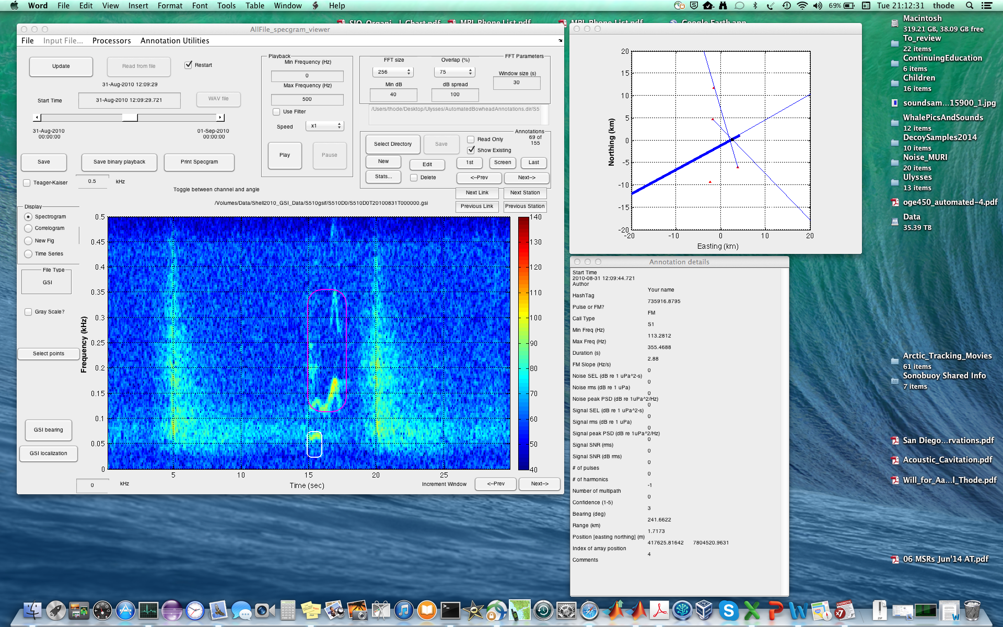

Figure 1: Ulysses display when linked annotation 69 is selected. Note that besides the annotation detail window, a plot of the location of the call is also included.

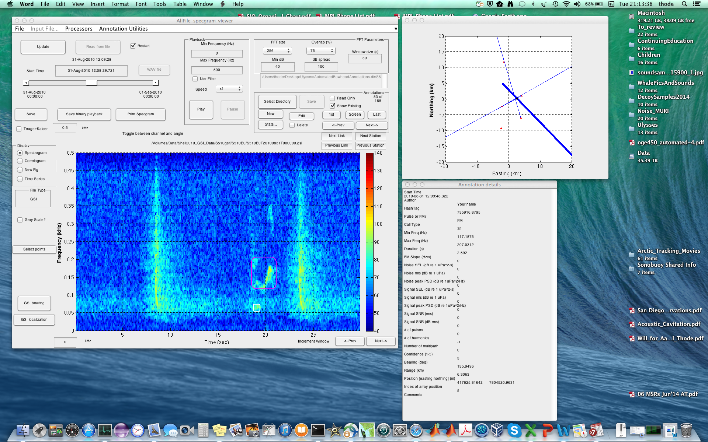

Figure 2: Ulysses display when the “Next link” button is hit.

One can move back and forth between annotations within a single file by selecting “<-Prev” and “Next->”, as with a regular annotation file. However, pressing the “Next Link” and “Previous link” buttons provides a new direction to move.

By hitting one of these buttons, the program “jumps” to the nearest linked annotation. It does this by saving the current annotation file, loading a new file and new annotation file, and displaying the result. Figure 2 illustrates what the Ulysses display looks like after “Next Link” is selected. Note that the position of the call in the map has not changed, only the highlighted bearing changes, reflecting the fact that we are now viewing a file from DASAR 5E instead of 5D. Note that the title above the spectrogram tells you the current title, and that the total number and current index of the annotations will change; each annotation file may have different numbers of annotations. By continuously pressing the “Next Link” or “Previous Link” button one can cycle through all the annotations currently linked to this particular call. A “Next” button advances to the DASAR station with the next highest letter (moves north to the next station), while “Previous” moves south. If one is at the northernmost DASAR 5G and presses “Next,” then the program cycles down to the southernmost DASAR 5A again. Thus “cycling through the links” means continuously pressing the “Next Link” or “Previous Link” button until one arrives back to the original annotation, in this case, annotation 69 of file 5D.

How does this work? Each annotation has a unique ID called a “hashtag”. Whenever you create a new annotation, a new hashtag can be created, or a hashtag belonging to another annotation can be copied. If two annotations have the same hashtag, then that means they are part of the same call. For example, two harmonics drawn with two separate annotations can be linked with the same hashtag to indicate that they are part of the same call.

A linked annotation not only has its hashtag, but it also contains a list of other annotation files “link_names” and a list of other hashtags that allow it to locate the linked annotation on another file. In general, linked annotation files must be in the same folder.

What about DASARS (or “stations”) that aren’t currently part of this linkage? By pressing the “next station” or “previous station” buttons, one can jump to adjacent DASARS, regardless of whether the current annotation is linked to it or not. This feature will be useful when adding linkages (additional calls) to an annotation. Go ahead and press “next station” when looking at the 5E file in Fig. 2. A question box will appear:

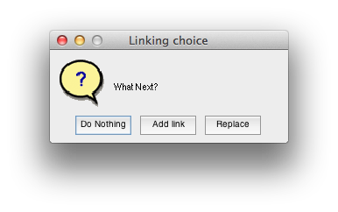

Select “Do Nothing,” and you will be looking at the same time period as 5E, but now in the 5G window. By hitting either “Prev Link” or “Prev station” you will return to 5E and the annotation shown in Fig. 2.

**Goals of Analysis**

There will be three types of editing that can be performed with linked annotations: (1) Changing the bounding box of an annotation; (2) adding a harmonic to an annotation; (3) fixing an incorrect linkage between annotations, (4) adding a new linkage between annotations.

**In general, the editing sequence will be**

**(1) add new linkages;**

**(2) fix incorrect linkages;**

**(3) fix bounding boxes, and then finally**

**(4) add harmonics.**

Let’s begin by returning to Figure 1. Clearly the bounding box needs to be changed to cover one harmonic instead of two, and a second harmonic bounding box needs to be added. Hold off on that—remember, we should add new linkages first.

**Adding a new linkage**

Press “Previous Link” twice, so you are in file 5B (Figure 3). In general, you should check adjacent DASAR stations for call detections, in this case DASAR 5A. To force a shift to this station, select “Previous Station” NOT “Previous link”. You will see the “Linking choice” box above. Now press “Add Link”.

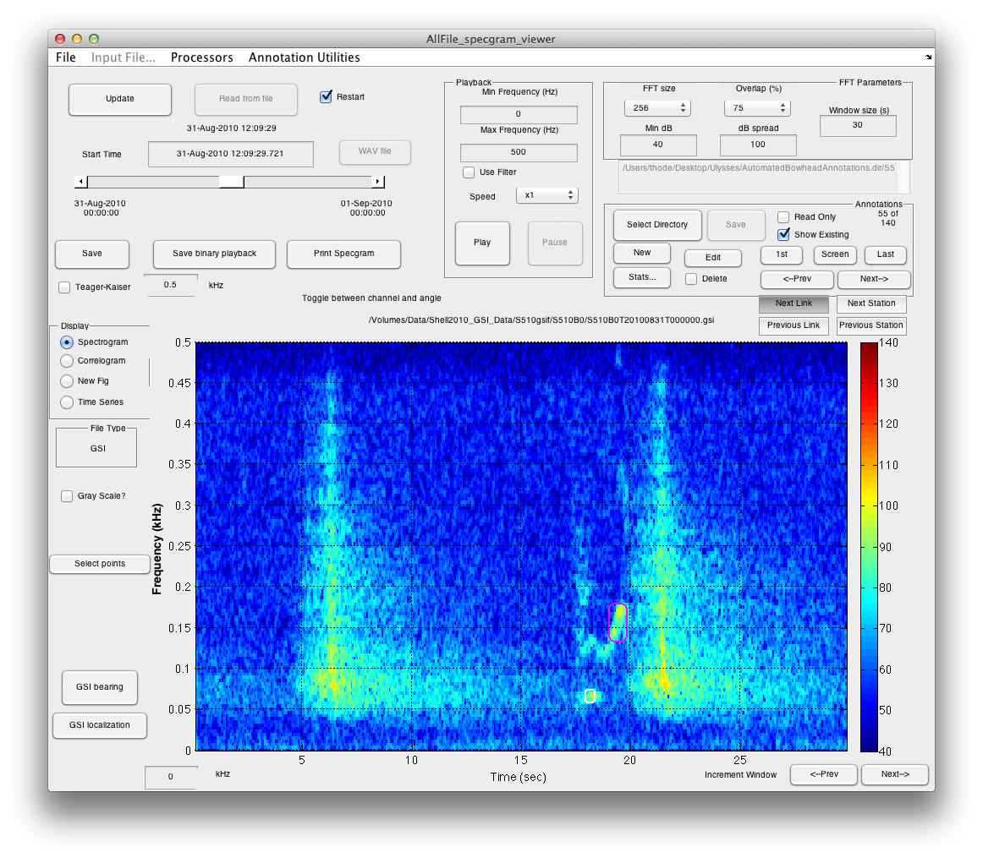

Figure 3: Annotation 55 of 140 in DASAR 5B.

You will be asked to click two points on the screen. Click so that the red box appears as shown in Figure 4, select “FM” from the menu command, and select “Completely New” from the subsequent “Annotation status” box below:

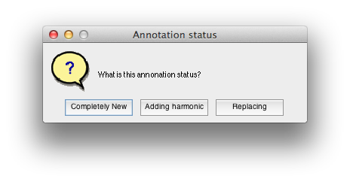

A large “Annotation for event” edit box will appear—add your name under “Author” and click “OK”.

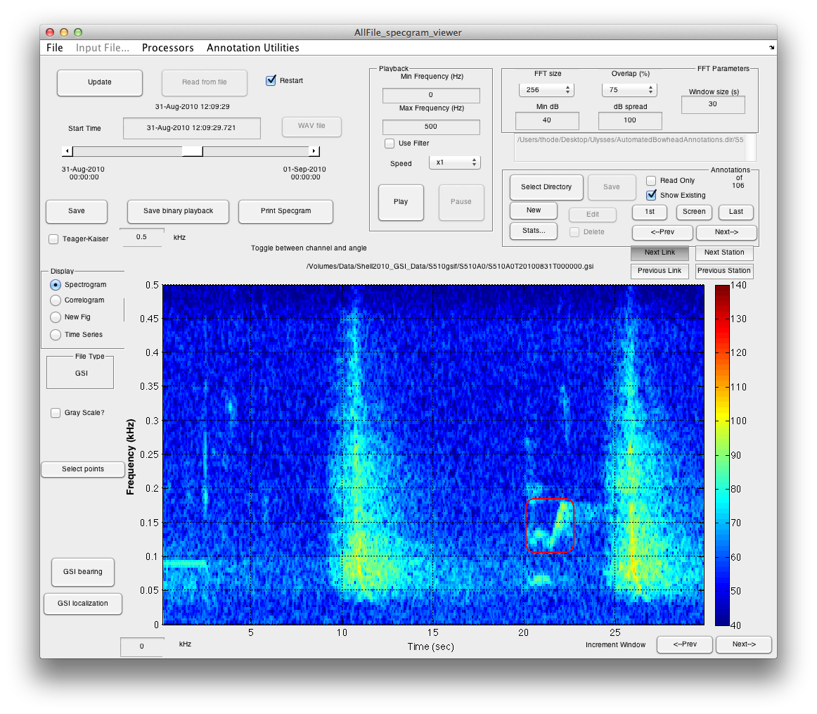

Figure 4: All Ulysses windows for annotation 39 of 107, DASAR 5A, once manual link has been added.

Figure 5 shows that the map figure now has a new bearing and an updated localization!

Now the important part, **whenever a new link is added or changed, “cycle” through the rest of the links until you return to the new link.** This allows information about the new linkage to be stored in all the annotation files; otherwise, if you open up an annotation file for 5D in the future, it won’t know about this linkage. So go ahead and hit either “Next Link” or “Prev Link” until you are back to Figure 4. You can actually see the map window update the new bearing every time you click.

You might want to check out whether the call exists on the northernmost station 5G. So when you are back in file 5A, click “Previous station” to force a move to 5G. You should see no signal there, so select “Do Nothing” from the Linking Choice window. Hit either “Previous Station” or “Next Station” to return to a DASAR that is part of a linkage.

There are no incorrect linkages, so next we’ll learn about fixing bounding boxes.

To summarize, to add a linkage:

1. link to an annotation that is adjacent to a DASAR without a link.
2. Press “Next station” or “Previous Station”
3. Select “Add Link,” in the Linking Choice box, then draw a bounding box.
4. Click “FM,” then “Completely New” in the Annotation Status box.
5. Enter your name, if needed in the Edit box, then click “OK”.
6. Verify that the new bearing has been added to the map view.
7. **Cycle though all links, returning to new link.**

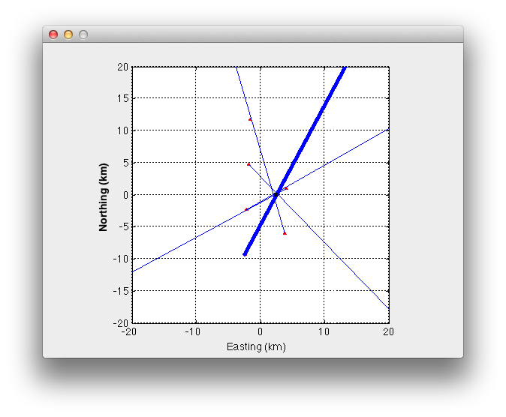

Figure 5: DASAR 5A (southernmost DASAR) is now part of the linkage.

**Changing bounding box**

There are two ways to change the size of the bounding box for a given annotation. The safest is to select the “edit” button when the annotation is highlighted by the pink bounding box, and manually adjust the min freq, max frequency, and duration, and then hit “OK”.

Unfortunately, you cannot change the start time of a bounding box this way. So the second way to do this is to create a new annotation, and delete the old. Do these steps:

1. Make sure the annotation box you want to change is highlighted in pink. As a precaution, you can hit the “Next” and then “Prev” buttons to check.
2. Select “New” annotation and click twice to define your new box. It is OK to overlap with the original box!
3. A new window will appear:

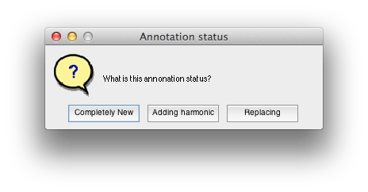

1. Select “**Replacing**”. This copies the hashtag of the current detection into the new detection, preserving all linkages.
2. The edit window will appear: remember to enter your name as “Author”. Note that you can see the names of the other linked annotation files and other annotation hash tags. Click on “OK” to close the edit window.
3. The new bounding box should now be pink, and the original box now white. Click “Next” or “Prev” as needed in Annotations to return to the original bounding box. Check that all the thin blue lines on the map view are the same between the old and new annotation (the thick blue line may change slightly).
4. When the old annotation is highlighted, select “delete” checkbox and then press “Delete”. The button will revert to “Edit”.
5. Save the result. **Cycle through all links.** You can change the bounding box on each link while cycling, but make sure you keep cycling in only one direction, until you have done a complete cycle through all links **after** you have completed the last change of a bounding box.

Go ahead and practice on the annotation in Figure 1. Make it look like Figure 6. While you are at it, go ahead and link down to DASAR 5B (Figure 3) and readjust that bounding box as well. You will have to create a new annotation and delete the original for 5B, since the start time will shift.

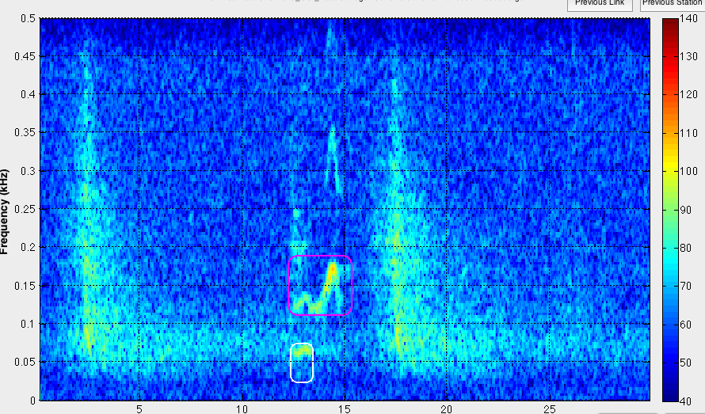

Figure 6: Figure 1 after bounding box has been edited.

**Adding/changing harmonics**

Add harmonics **only** after all links have been fixed and primary bounding boxes adjusted.

To add a harmonic or other related component to a current annotation, do the following steps. Please locate Annotation 68 of 155 in the S510D0T20100831T000000.gsi file (Figure 1) as a walkthrough. Annotation 59 of 156 for the 5D DASAR also gives some good practice…

1. Select the original (fundamental) frequency component, open the edit window, and enter the number of harmonics you will be adding (including the base harmonic).
2. Make sure the original bounding box is highlighted in pink, then select “New”. Select the harmonic you want. (Figure 7).
3. Select “Adding harmonic” in the Annotation Status box. This copies the hashtag of the current selection to the new selection (along with the number of harmonics).
4. Save your work and click on the “Prev” and “Next” annotation buttons to switch between the original detection and the harmonic. The map should change very little between the annotations, and the “HashTag” entry in the Annotation details window should not change between the annotations.
5. If there are other harmonics, continue adding them. It does not matter which harmonic bounding box is highlighted in red. For example, note the 50 Hz component surrounded by bounding box in Figure 6. Go ahead and delete the original bounding box, then add a bounding box back as a harmonic.
6. If harmonics exist on one file, they probably exist on other files, so select “Link Up” or “Link down” and repeat steps a-e for the other linkages. Be sure to save the annotations before hitting the link buttons—they should be automatically saved for you, but it is best to develop good habits early on.
7. Note that when you link up or down the annotations, and two annotations share the same hashtag, then the one that is detected first (earliest bounding box left edge) will be the one selected. So don’t be afraid if you don’t see harmonics highlighted in pink as you link up or down.

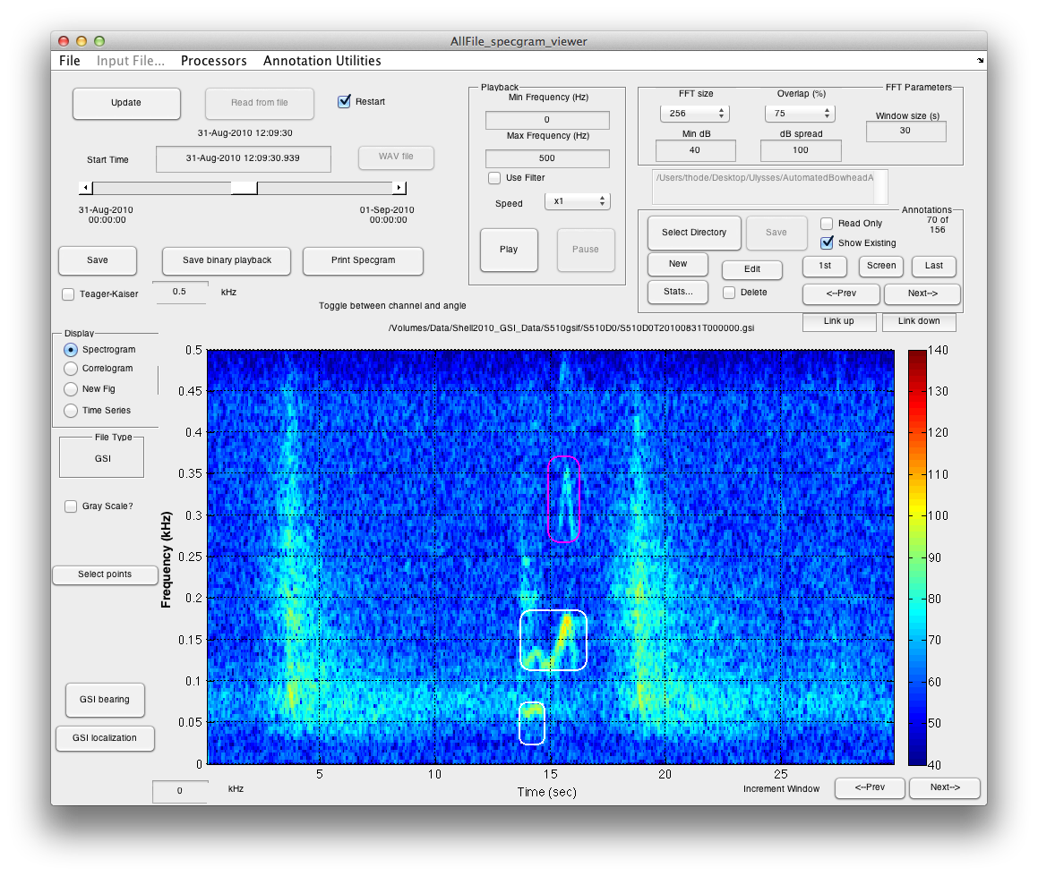

Figure 7: Final annotations for harmonic example. Note that the bounding box for the 50 Hz component has been deleted, then re-added as a harmonic.

**Changing a bad link**

The linked annotations are initially generated by a computer program (**Thode ref), and mistakes due happen. Please locate Annotation 75 of 156 on DASAR 5D (Figure 8). Note that the bearing for the selection in the red box does not seem to match the other linkages on the map (Figure 9). Go ahead and cycle through the links to understand what is going: the FM downsweep (highlighted in the other white box ) should be linked to the other annotations.

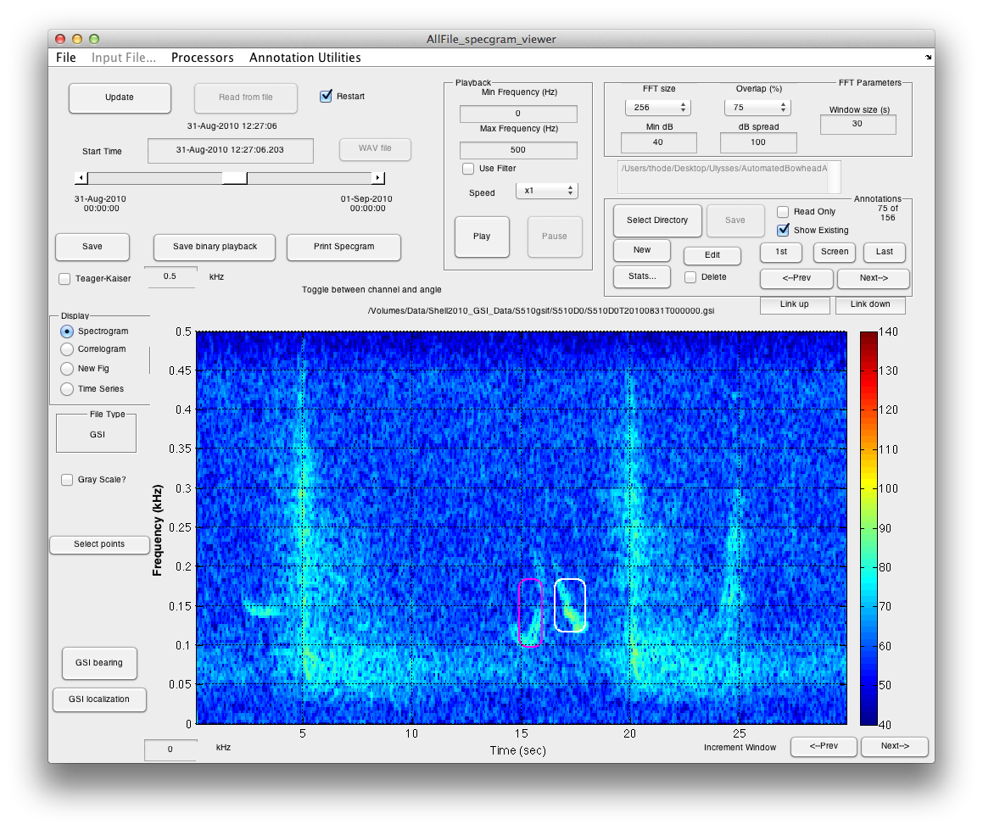

Figure 8: Annotation 75 of 156 on DASAR 5D, illustrating bad link.

Before fixing a link, remember the editing sequence: add all links first. To that end, we should check out DASARS 5B and 5G. Nothing at 5B, but look at 5G, when we select “Next station” from 5E (Figure 10):

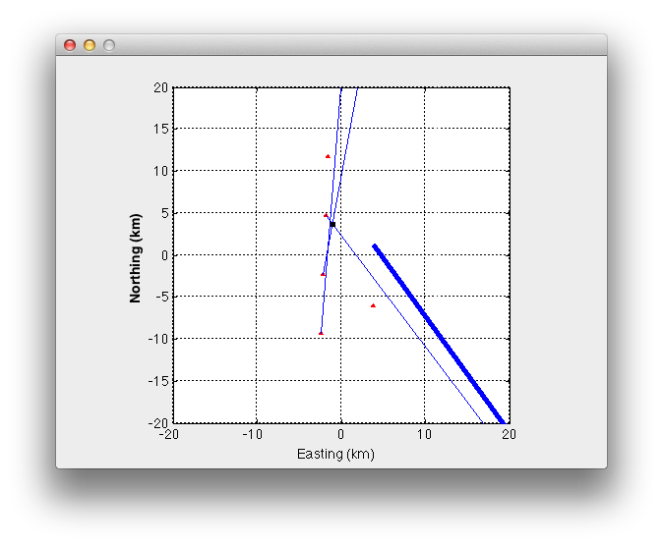

Figure 9: Example of bad links for annotation 75.

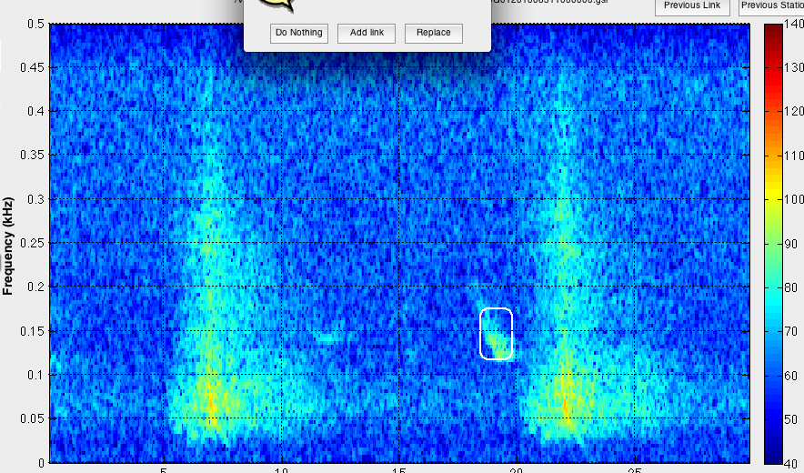

Figure 10: When adding a new link, you might see that a signal is already selected. Here is 5G with a signal that should be linked to Figure 9.

The computer already assigned this downsweep to a second linkage! What to do? No problem, just select “Add link” from the linking choice box, and make a new bounding box that overlays the existing one:

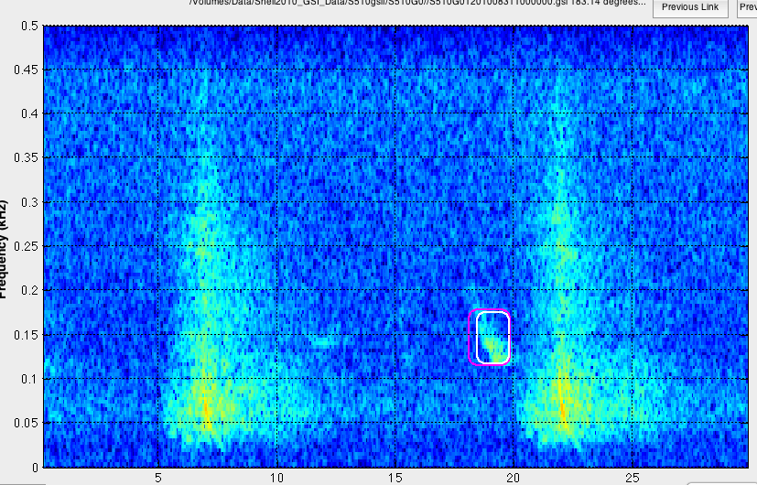

Cycle through all links to make sure all annotations have these linkages. Now we can fix 5D:

1. After adding all new linkages, switch to link that needs to be fixed (replaced):
2. Select “New” from annotation section.
3. Select new bounding box (OK if one already exists).
4. Select “Replacing” from Annotation Status.
5. Hit OK in edit window, after adding your name to the edit.
6. Check the map window to see that bearing makes sense:

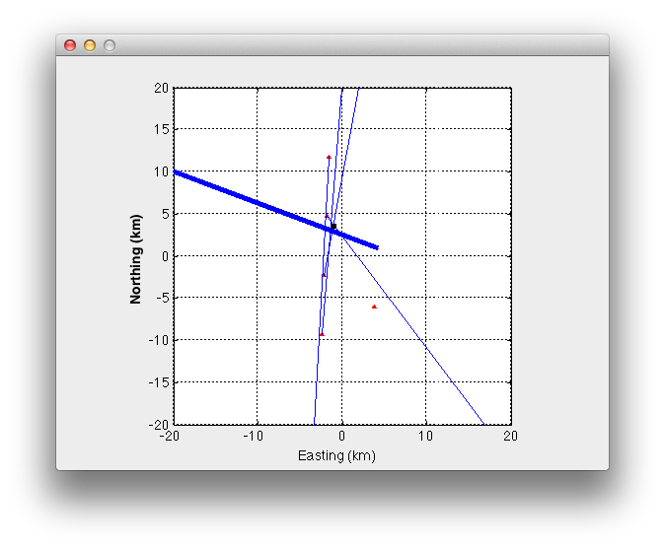

1. Hit “<-Prev” or “Next->” button (not any link or station button) and delete the original bounding box by selecting the “Delete” checkbox and hitting the “Delete” button.
2. Highlight the new Bounding box in red and **cycle through all linkages**, so that the new bearing is recorded in all annotation files.
3. Fix other problems: Note that 5E is linking to the wrong detection now as well. So make a new bounding box, hit “replace” as an annotation choice, then delete the other two bounding boxes.
4. Once all linkages are fixed, then adjust bounding boxes, and then add harmonics.

**Deleting a link completely**

The last topic in fixing incorrect linkages is the case when a link exists on a DASAR that shouldn’t be there, and the signal of interest isn’t there. For example, a link has been made to an airgun signal on one DASAR, but links are to the same whale call on the others:

1. Switch to bad DASAR and highlight bad linkage.
2. Check “delete” box **but do not click “Delete” button.**
3. Click “Next Link” and following box will appear:

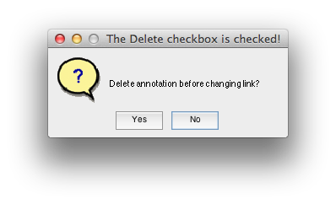

1. Select “Yes,” and bearing will vanish from map.
2. **Cycle through remaining detections until the bad link vanishes from all maps…**

**Summary**

**The editing sequence is as follows**

**(1) add new linkages using the “Next station” and “Previous Station” buttons. If a signal is not present at a station, ALWAYS return to your previous link.**

**(2) fix incorrect linkages.**

**-If a correct link exists, replace bounding box.**

**-If no correct link exists, delete the link completely**

**(3) fix bounding boxes so that only a single harmonic exists.**

**(4) Finally, add harmonics to links that have them.**